SMART PUBLIC RESTROOM

***Abstract***

*IOT is a relatively new technology and is getting very popular very rapidly. The main aim of IOT is to connect electronic or mecha-electronic devices together with the help of a network. By using IOT, we will be designing a monitoring system for public toilets so that managing them becomes easy for higher authorities. IOT devices will be used, namely microcontrollers analogue sensors along with a front end for UI and a backend for future analysis purposes.*

***Keywords -*** *IOT, Smart toilet, Arduino, NodeMCU****.***

## INTRODUCTION

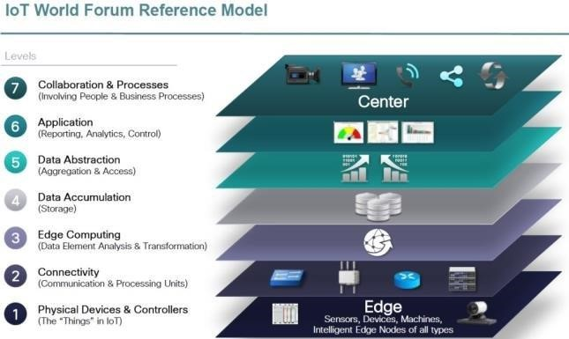IOT is the technology of the future. It is getting very popular due to its vast application possibilities. A general idea behind IOT is a network of various devices being electronic or mechanical connected together to perform a certain task in unison. These tasks can be repetitive and can be effectively handled by IOT. Based on the functionality of the IOT system, they are divided into tiers, and each tier represents a level of the IOT system. We will be designing an IOT system for monitoring the hygiene of public toilets by various using various sensors. These sensors will be connected to a microcontroller which will send the data to the backend, where it will be stored and processed. This data can be fetched and monitored by using a frontend, either an android app or a website. The objective of this system is to keep track of all cleaning activities so that the toilets are kept clean and hygienic at all times. The technical working of the system starts with parameters used to identify the hygiene of the toilet. Various sensors are available, like ammonia sensor, H2S gas sensor, turbidity sensor, etc. can be used. Depending upon the complexity of the system, microcontrollers can be used.

According to the tiers, the proposed system falls till tier 4 as our system will be able to store data that comes over a network.

## LITERATURE REVIEW

In terms of global research, many developed countries have already developed fully automated smart toilets which are capable of handling all the tasks from data gathering to automatic cleaning of the toilets without any human interaction except for the system maintenance. This fully automated system requires a lot of capital and can’t be applied to all public toilets. In developing countries, a system that can auto flush is in place. For monitoring purposes, it is done by old fashion on paper methods which track activities of the toilet usage and cleaning process. For many regions, the toilets are neglected completely.

## REQUIREMENTS

1. ***Software requirements***

Software requirements for the proposed system are all free to use and can be acquired on an easy basis. Software used are

* + Arduino IDE
  + HTML
  + XAMPP server

1. ***Hardware requirements***

* Arduino UNO

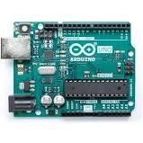

* + 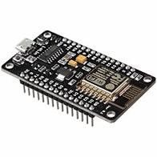NodeMCU
  + Breadboard
  + Connecting wires
  + MQ-135 gas sensor

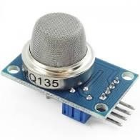

* + Ultrasonic and IR sensor

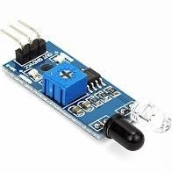

* + 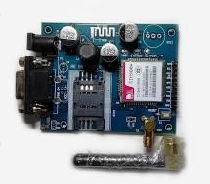GSM module

## METHODOLOGY

Our proposed system is a smart monitoring system designed to monitor the hygiene of public toilets. Unhygienic toilets can be detected by different parameters such as water levels, and various gases evolved, humidity, temperature etc. We will be using the gases present in this toilet as our primary parameter. Ammonia gas is the most dominant gas that can be sensed in an unhygienic toilet. Also, we will be keeping track of the number of persons using the toilet and also the track records of the workers who clean the toilet. We will be using the MQ-135 gas sensor determine the amount of ammonia present in the room. A threshold value will be set, and if the value of ammonia present exceeds that value, then the toilet will be marked for cleaning. The buzzer will be the physical indication for the people and staff present in the toilet. The Ultrasonic sensor will be installed at the entrance, and the value will change if a person enters or leaves the toilet. At each change in value, a count variable will be incremented,

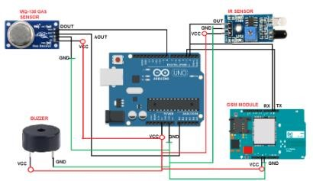By dividing it by 2, we will get the count of people using the toilet. All these sensors will be connected to the Arduino UNO, which will handle these sensors and will transmit the sensor data to the NodeMCU using serial communication. Once the Node MCU receives the sensor data, it will broadcast it to the database over a network. A user-friendly GUI or website will be provided for higher authorities for managing the system. GSM module will be used to send a message over their SIM card number for direct contact without the internet. GUI will be provided to the staff where they can get notifications and messages directly from the central office.

* 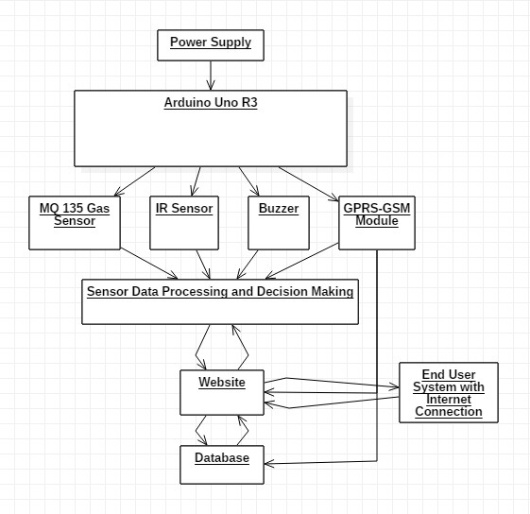Data flow diagram
* 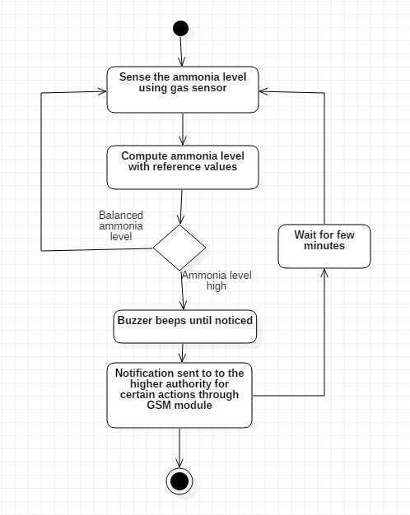UML diagram

C PROGRAM

#include <stdio.h>

#include <wiringPi.h> // Library for GPIO control (on Raspberry Pi)

#include <wiringPiI2C.h> // Library for I2C communication

#include <unistd.h>

#include <MFRC522.h> // Library for RFID reader

// GPIO pins for sensors (change these to match your setup)

#define SMELL_SENSOR_PIN 17

#define IR_SENSOR_PIN 18

#define SONIC_TRIGGER_PIN 23

#define SONIC_ECHO_PIN 24

// Function to read data from the smell sensor

int read_smell_sensor()

{

// Add your code here to read from the smell sensor

// and return the data.

return 0;

}

// Function to read data from the IR sensor

int read_ir_sensor() {

// Add your code here to read from the IR sensor

// and return the data.

return 0;

}

// Function to read data from the sonic sensor

int read_sonic_sensor() {

// Add your code here to read from the sonic sensor

// and return the data.

return 0;

}

int main() {

wiringPiSetup(); // Initialize wiringPi library (Raspberry Pi GPIO)

// Setup GPIO pins for sensors

pinMode(SMELL_SENSOR_PIN, INPUT);

pinMode(IR_SENSOR_PIN, INPUT);

// Setup GPIO pins for sonic sensor (if using WiringPi)

pinMode(SONIC_TRIGGER_PIN, OUTPUT);

pinMode(SONIC_ECHO_PIN, INPUT);

// Initialize RFID reader

MFRC522 mfrc522(0, 0);

while (1) {

// Read data from the smell sensor

int smell_data = read_smell_sensor();

// Read data from the IR sensor

int ir_data = digitalRead(IR_SENSOR_PIN);

// Read data from the sonic sensor

int sonic_data = read_sonic_sensor();

// Read data from the RFID reader

if (mfrc522.PICC_IsNewCardPresent() && mfrc522.PICC_ReadCardSerial()) {

printf("RFID Tag UID: %X %X %X %X\n",

mfrc522.uid.uidByte [0], mfrc522.uid.uidByte [1],

mfrc522.uid.uidBIyte [2], mfrc7522.uid.uidByte [3]);

}

delay(1000);

}

return 0;

}

**CONCLUSION**

This system will be able to overcome the big problem of poorly maintained public toilets. Since most of them are cleaned by workers, their activities we not being detected, resulting in toilets being unclean most of the time. This system will be able to track their activities effectively and provide a great way for higher authorities to maintain them in real-time. This will result in increased efficiency of the labour and a decrease in extra cost and efforts. The common people will be able to use the regularly clean toilet than before, which will eventually increase the toilet usage. For future development of this proposed system, mecha-electronic elements can be added, which will respond to the outputs of the sensors and provide fully automated cleaning